Автор: Гаврилова Алла Владимировна

Урок-обобщение по теме «Австралия» к учебнику английского языка для 6 класса О.В. Афанасьевой и Л.В. Михеевой

Аннотация: Данный конспект урока-обобщение представляет собой разработку открытого урока по теме Австралия в школах с углубленным изучением английского языка. Данный урок предполагает работу в парах и группах, что позволяет ученикам максимально развивать навыки говорения.

Topic: Australia
Type of the lesson: round-up lesson
Aim: 1.to sum -up the facts about Australia, its states and territories, specific features;
2.to develop dialogical and monological speech to the topic;
3.to practice continuous tenses: Present, Past, Future

Procedure:

1.Greeting: Good afternoon, children! Today we are going to summarize our knowledge to the topic “Australia”. We are going to revise main information about this country, repeat the words to the topic as well as the continuous tenses.

2.Warm up: let's play the game. There are words on the blackboard: a swamp, an apricot, to inhabit, vast, a hemisphere, a berry, humid, a pear, wheat. The class is divided into two groups, one student reads the definitions, the groups should find the word on the blackboard. The winner is the group that found more words.

3.A letter from a lost captain:
Group activity. The groups get two pieces of paper with a letter from a captain. There are some missing words. The groups should write down missing words:
Dear friends,
I need your help! I'm writing to you from an unknown and. Here I give you some information about the country. The map and tasks can help you to find and save me.
Good luck
It's a l) c- - - - - - -t, an 2) i - - - - d, and an 3) i----- t country. It borders on 4) A - - a, 5)A- - - - - - - -a, and
6)N –wZ-----d. The 7) I- - - - n Ocean washes it in the west and the 8) P ----- с Ocean washes it in the east. It is also washed by the Timor, the Coral and the Tasmanian Seas.
The 50% of the land is dry and uninhabited 9) d - - - -t (). There are 3 of them: the Great Sandy, the Great Victoria, the Gibson. They are in the west. People live mostly in the south and southeast.In the northeast 10) t - - - - - -l f - - - - ts cover the coast.

4.Cards with information about Australia. Work in pairs. Students get the cards, one card contains facts, the second one key words to ask questions. They ask each other questions and fill in the table.

Card A
1. Capital
2. Hemisphere
3.Largest city
4.Official language
5.Number of states and territories
6.Monarch
7.Population
8.Discovered by
9.Kevin Rudd

Card B
Canberra
Southern Hemisphere
Sydney
English
6 states and 2 territories
Queen Elizabeth II
18 million people
Captain Cook in 1770
Prime Minister

5.Work in groups. There are two maps of Australia, members of each group should write the names of the states, territories and their capitals.
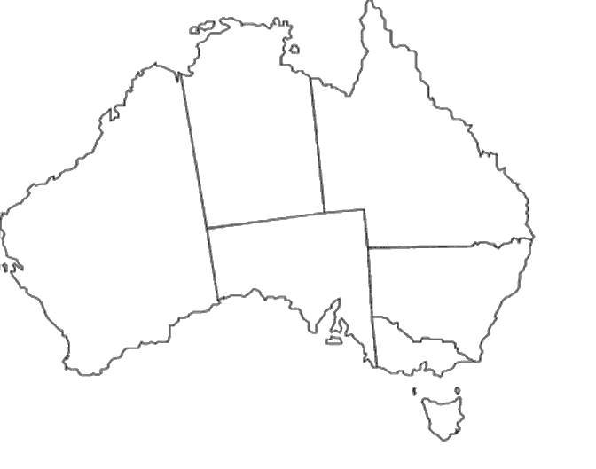

6.Whole class activity. The students give more information on each of the state.

7.Checking hometask. At home you had to answer the question: “What place in Australia would you like to visit and why?”and find some pictures and additional information. Now present the results of your work. The students show pictures and tell about the place they would like to visit.

8.Now, let's learn more facts about Australia. Work in pairs. Students get the stripes of paper with questions and answers, they should match them.

What is the official name of the country?
The Commonwealth of Australia.
When was the Commonwealth of Australia formed?
In 1901
What kind of state is Australia?
Constitutional Monarchy.
What is the capital of Australia?
Canberra
Who is the Head of State?
Queen Elizabeth II
What colour is the flag of Australia?
blue, red and white.
Which are the national colours?
Green and gold.
What animals can be seen on Australia’s coat-of-arms?
Kangaroo and emu.

9.Grammar – quiz. Let's revise the continuous tenses and complete the sentences about Australia.

Test
- My children _________with koala bears in the national park right now.
(are playing, were playing, will be playing)

- My brother ______about wildlife in Australia at 4 o’clock yesterday.
(is reading, was reading, will be reading)

- When the father was sleeping, his children _______a film about dingo dogs.
(were watching, will be watching, are watching)

- I ______Sydney soon.
(shall be visiting, am visiting, was visiting)

- ___he_____his friends in Melbourne this time next week?
(will___be meeting, is____meeting, was_____meeting)

- Her brother ______English this time next year.
(isn’t learning, weren’t learning, won’t be learning)

- We ______about the continents at the moment.
(am studying, are studying, were studying)

- The girl ______in the ocean, when she saw a ship.
(were swimming, was swimming, is swimming)

- ____ our scientists____ new lands next season?
(will _____be exploring, are____ exploring, were ______ exploring)

- I______ at the eucalyptus tree now.
(am looking, was looking, shall be looking)

10.We have done a lot of tasks and you must be tired, let's have a rest and sing a song about the most popular bird in Australia. What is it? Right! Kookaburra! At the previous lesson we filled in the gaps now let's sing the song.
Kookabura Song Lyrics
Kookaburra sits in the ____ gum ___
Merry, merry ____ of the ____ is he
______, Kookaburra!______, Kookaburra!
Gay your _____ must be
Kookaburra sits in the ___ gum _____
_______ all the gum drops he can see
____, Kookaburra! ____, Kookaburra!
_______ some there for me
Kookaburra sits in the ____ gum ___
Merry, merry ____ of the ____ is he
Laugh, Kookaburra! Laugh, Kookaburra!
Gay your _____ must be
Kookaburra sits in the ___ gum _____
_______ all the gum drops he can see
____, Kookaburra! ____, Kookaburra!
_______ some there for me
11.Feedback: Blob's tree. Our lesson is coming to an end. You worked very well. I would like to know how you evaluate yourself and how you feel about our today's lesson. Please show on the picture where you are and explain why.
